# HTML Styles - CSS

## What is CSS?

Cascading Style Sheets (CSS) is used to format the layout of a webpage.

With CSS, you can control the color, font, the size of text, the spacing between elements, how elements are positioned and laid out, what background images or background colors are to be used, different displays for different devices and screen sizes, and much more!

## Using CSS

CSS can be added to HTML documents in 3 ways:

* **Inline** - by using the style attribute inside HTML elements
* **Internal** - by using a <style> element in the <head> section
* **External** - by using a <link> element to link to an external CSS file

The most common way to add CSS, is to keep the styles in external CSS files. However, in this tutorial we will use inline and internal styles, because this is easier to demonstrate, and easier for you to try it yourself.

## Inline CSS

An inline CSS is used to apply a unique style to a single HTML element.

An inline CSS uses the style attribute of an HTML element.

The following example sets the text color of the <h1> element to blue, and the text color of the <p> element to red:

## Internal CSS

An internal CSS is used to define a style for a single HTML page.

An internal CSS is defined in the <head> section of an HTML page, within a <style> element.

The following example sets the text color of ALL the <h1> elements (on that page) to blue, and the text color of ALL the <p> elements to red. In addition, the page will be displayed with a "powderblue" background color:

## External CSS

An external style sheet is used to define the style for many HTML pages.

To use an external style sheet, add a link to it in the <head> section of each HTML page:

**Tip:** With an external style sheet, you can change the look of an entire web site, by changing one file!

## CSS Colors, Fonts and Sizes

Here, we will demonstrate some commonly used CSS properties. You will learn more about them later.

The CSS color property defines the text color to be used.

The CSS font-family property defines the font to be used.

The CSS font-size property defines the text size to be used.

## CSS Border

The CSS border property defines a border around an HTML element.

**Tip:** You can define a border for nearly all HTML elements.

## CSS Padding

The CSS padding property defines a padding (space) between the text and the border.

## CSS Margin

The CSS margin property defines a margin (space) outside the border.

## Link to External CSS

External style sheets can be referenced with a full URL or with a path relative to the current web page.

## Chapter Summary

* Use the HTML style attribute for inline styling
* Use the HTML <style> element to define internal CSS
* Use the HTML <link> element to refer to an external CSS file
* Use the HTML <head> element to store <style> and <link> elements
* Use the CSS color property for text colors
* Use the CSS font-family property for text fonts
* Use the CSS font-size property for text sizes
* Use the CSS border property for borders
* Use the CSS padding property for space inside the border
* Use the CSS margin property for space outside the border

Css kodlari html kodlarini 3 formada deyisir

* Inline
* Internal
* External

Inline

Html elementlerine “style” attribute vasitesi ile baglanir

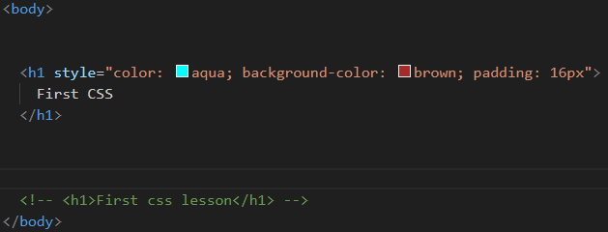

Internal

Css kodlari html sehifesi icerisinde olan head etiketinin alt etiketi olan style etiketi icinde yazilir

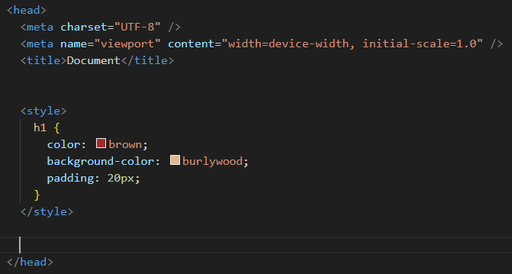

External css

.css tipli yaradilmis css faylinda kodlar yazilir hemin kodlar head etiketinin icinde teyin olunmus ve html fayli css faylina link tegi vasitesile baglanilir

Link tegi head etiketin alt etiketi kimi istifade edilir

A tegi ise body etikinin alt etiketi kimi istifade olunur

ID ve Class

Unikal html elementini teyin etmek ucun id attributundan istifade olunur.Yalniz her html elementi ozune mexsus id-e sahib ola biler

Html elementlerini qruplara bolub uzerlerinde emeliyyat aparmaq ucun(adeten dizayn css ile) class attributundan istifade olunur.

Selectors

Selector deyismek,dizayn etmek istediyiniz html elementini secmek ucun istifade olunur

Id atributu #(dyes) vasitesile cagrilir(html terefinde link teqi)

Padding-iceriye dogru bosluqlardir

Class atributu .(noqte) vasitesile cagrilir

1 tege 1id vere bilirik,amma bir nece dene class vere bilirik

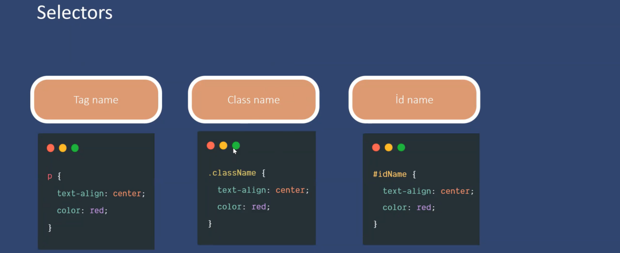

Ilk hansi?

Selectorlara gore ilk hansi dizaynin tesir edeceyini bilmek ucun asagidaki siralamaya goz ataq:

Inline css

Id selector

Class selector

Tag selector

Browser defaults

Margin

Elementin serhedlerinden kenara dogru bosluq vermesidir. (mesafe)

Saat eqrebi istiqametinde

Margin-top top,right,bottom,left

Margin-right

Margin-bottom

Margin-left

Margin: 50px 100px -bele halda 50px asagi ve yuxarini belli edir,100px ise sagla solu belli edir.

Eger her birin terefin olculeri ferqlidirse-meselen top 50, botton 30,right 100,left 120-dirse,onda saat eqrebi istiqametinde 50,100,30,120

Margin-inline: 50px 30px—50sag,30sol

Tovsiye

Id atributundan JS-de

Class atributundan css-de

Padding

Elementin iceriden bosluq verilmesidir

Padding-top

Padding-right

padding-bottom

padding-left

box-sizing:content-box

box-sizing:border-box

*{

Box-sizing:border-box;

Margin:0.

Padding: 0.

}

Descendant

Verilmis element selectorlarini parent child siralayaraq secir.Yəni yazilan element en ustu elementin icerisinde olan element coxlugu secilir.

Tutaq ki,div(class adi box) elementinin icerisinde ul elementi onunda icerisinde li ve a elementleri vardir,onlara style vermek ucun(divin icindeki diger teqlerden ayirmaq ucun)

.box ul li a{}

Eger 2 ferqli divin icerisine eyni style vermek isteyirikse onda vergulle yaziriq,meselen

html

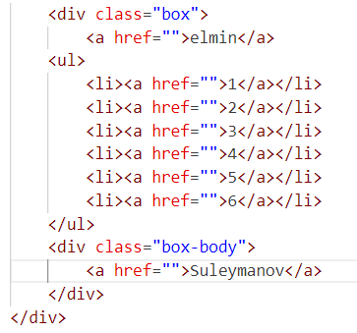

css

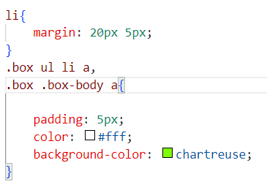

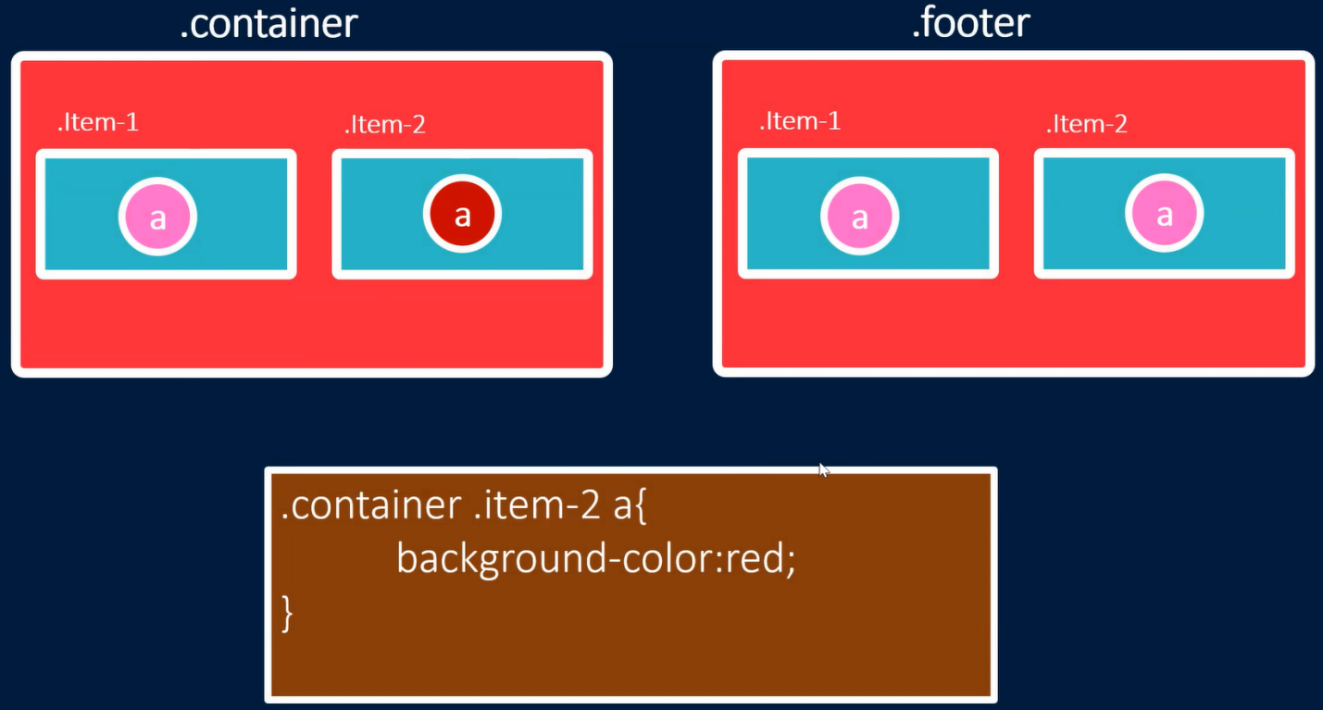

Multiple

Descendant usulla bir nece html elementi secmek ucun vergulden istifade olunur

Child selectors

Descendant usula benzeyir coxlu element secmek mumkundur

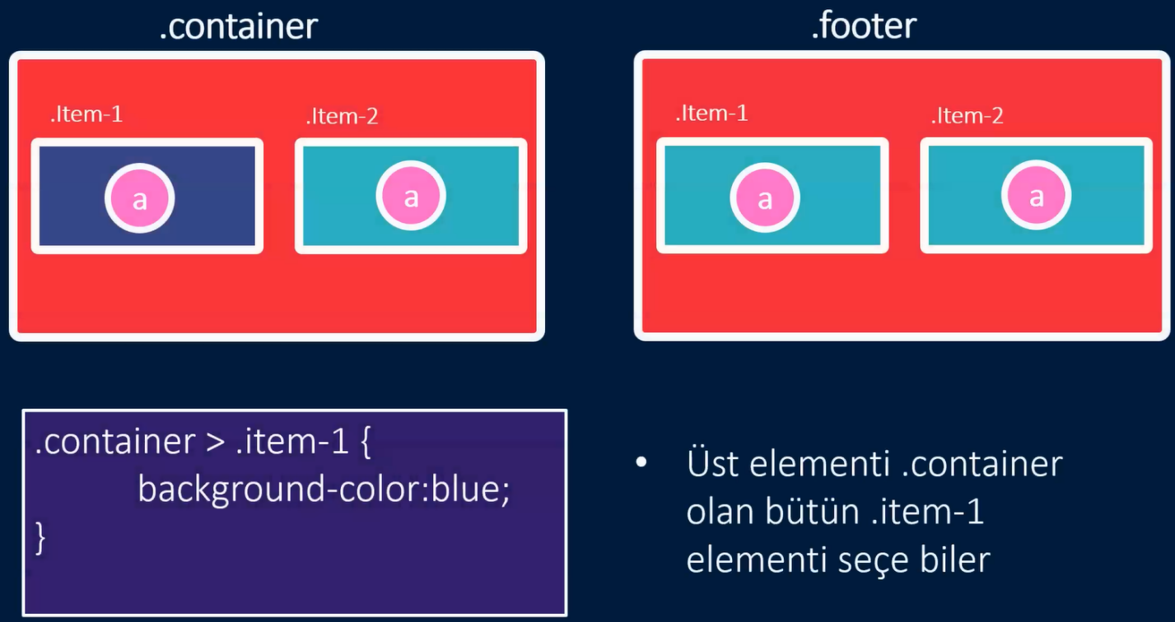

Adjacent selector(rastgele birini secir)

Verilmis elementle eyni seviyyede olan novbeti elementi secir.

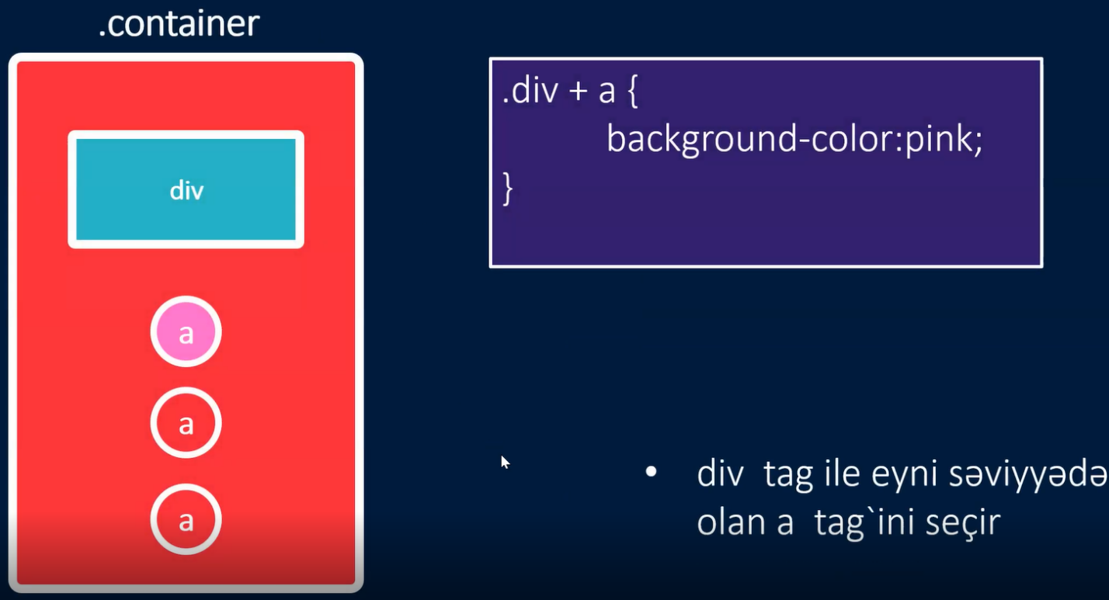

Verilmis class name-den sonraki ilk div name-e aiddir

General sibling selectors(butun hamisini secir)

Verilmis elementle eyni seviyyede olan novbeti butun elementleri secir

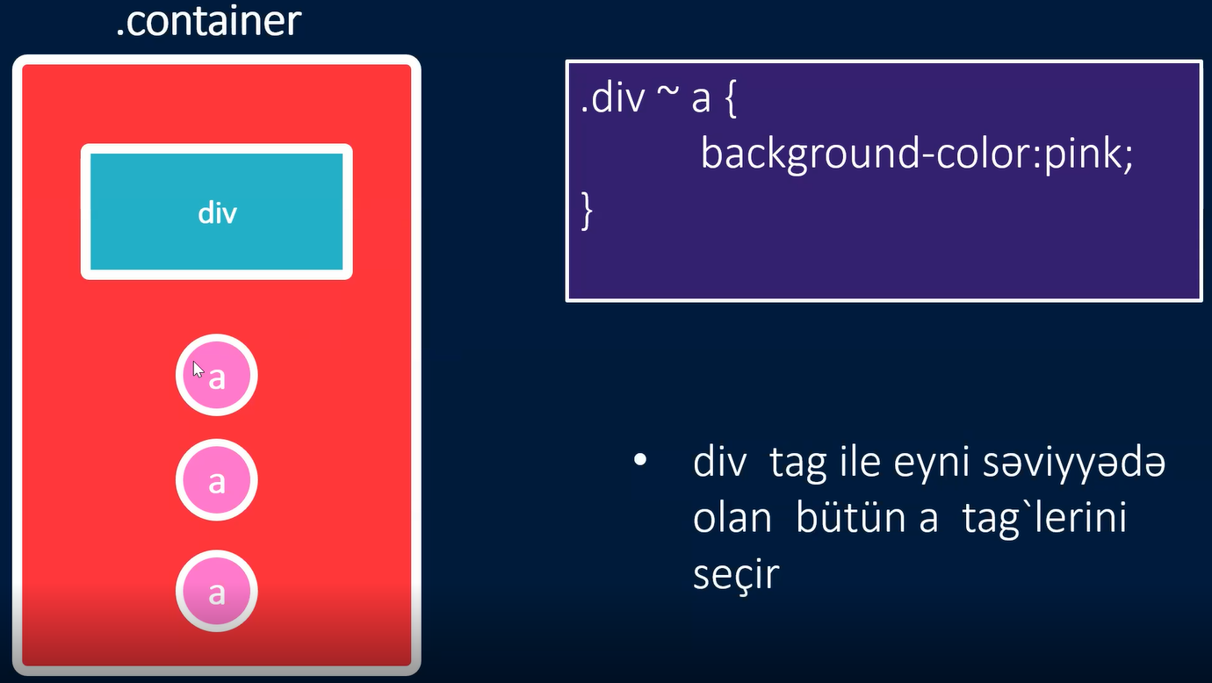

Verilmis class name-den sonraki name-lere aiddir

CSS

* Text
* Padding <https://developer.mozilla.org/en-US/docs/Web/CSS/padding>
* Borders
* Internal
* External

CSS text alignment

Text-align property metnin ufuqi nizamlanmasina nezaret etmeye imkan verir

* Left-soldan nizamlanmaga baslayir
* Right-sagda
* Center-merkeze dogru
* Justify-setiri tam tutur

<https://developer.mozilla.org/en-US/docs/Web/CSS/text-align>

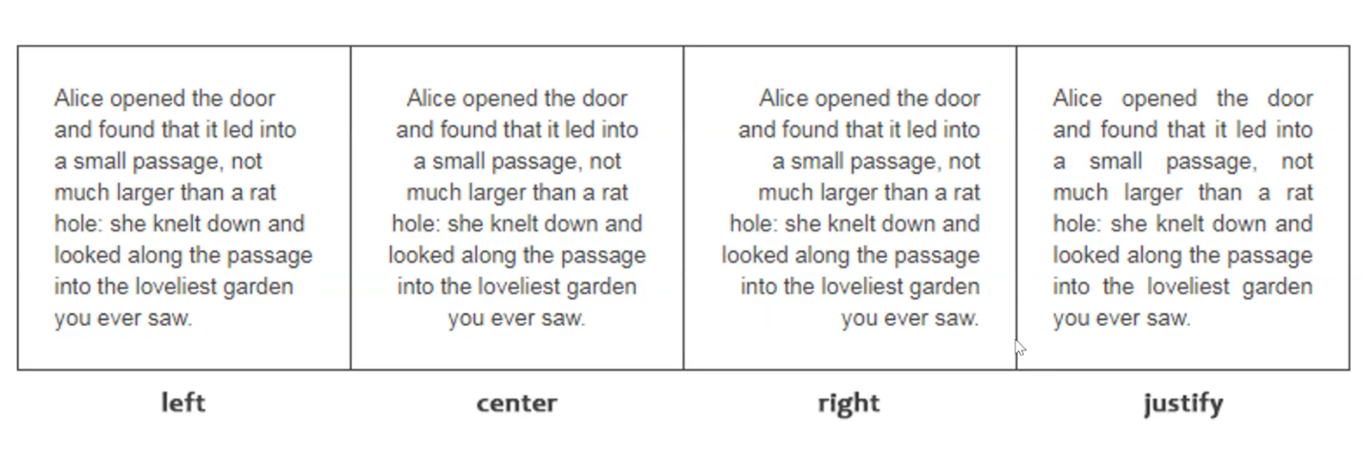

Vertical -align.

<https://developer.mozilla.org/en-US/docs/Web/CSS/vertical-align>

Elementin icindeki deyeri saquli olaraq nizamlayir

* Baseline:merkezde nizamlayir default olaraq
* Text-top:yuxarida nizamlayir
* Text-bottom:asagida nizamlayir
* Sub:index formasinda nizamlayir
* Super:quvvet formasinda nizamlayir

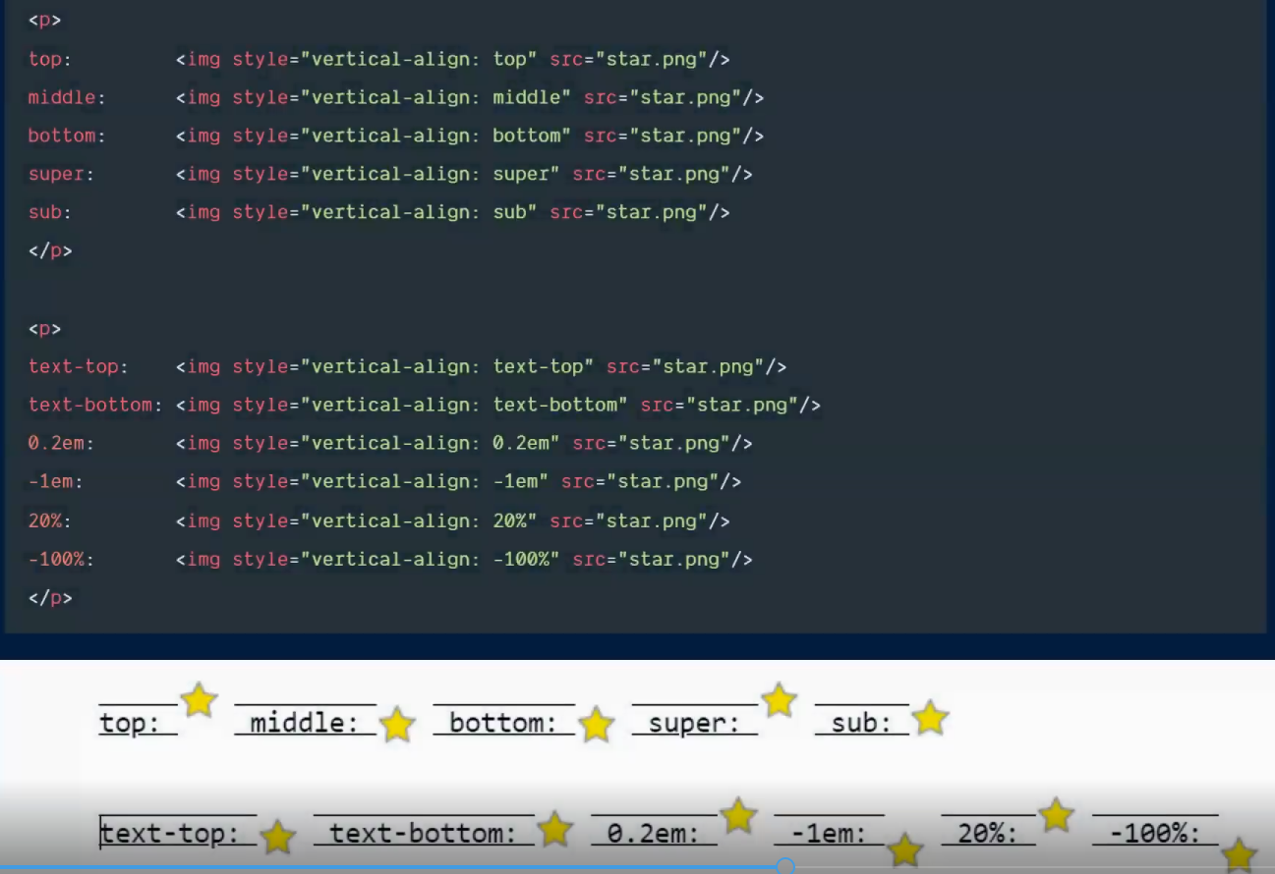

Text-direction

Element yazisini konteyner icinde saga ve ya sola dogru nizamlayir

* Rtl:right to left-sagdan sola nizamlayir
* Ltr:left to right-soldan saga nizamlayir

<https://www.w3schools.com/cssref/pr_text_direction.php>

<https://developer.mozilla.org/en-US/docs/Web/CSS/text-orientation>

Css text decoration

<https://developer.mozilla.org/en-US/docs/Web/CSS/text-decoration>

Text-in dekorasiyasini duzenleyir

* None:butun dekorasiyani silir
* Overline:ustunden xett cekir
* Line-through: uzerinden xett cekir(html-deki del elementinden ferqi odur ki, del istenilen soz ucun edir ayri ayriliqda amma line ise butov sozlerin ustunden )
* Underline: altindan xett cekir
* Solid-(arasdir)
* Wavy-(arasdir)

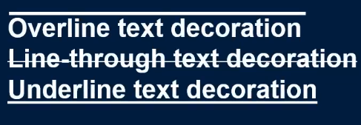

Css line-height

<https://developer.mozilla.org/en-US/docs/Web/CSS/line-height>

<https://www.w3schools.com/cssref/pr_dim_line-height.php>

Setirin uzunlugunu teyin edir

Text-transform property-i metni yazi formasini deyisdirmek ucun istifade olunur

<https://developer.mozilla.org/en-US/docs/Web/CSS/text-transform>

<https://www.w3schools.com/cssref/pr_text_text-transform.php>

Uppercase:yazini boyuk herfle edir

Lowercase:yazini kicik herfle edir

Capitalize:bas herflerini boyuk edir

Font-size-yazinin olcusunu deyise bilirik

Font-family-yazinin tipini deyismek ucun

Font-style-stilini

Font-weight-qalinligini

Font-display-(arasdir)

Borders

Elementin serhedlerinin dizayni ucun(rengi,qalinligi.ve s)

* Border-style:verilmis serheddin formasini teyin edir
* Border-width: verilmis serheddin olculerini mueyyen edir
* Border-color: serheddin rengini mueyyen edir
* Border-radius: verilmis serhedin kenarlarinin derecesini mueyyenlesdirir.

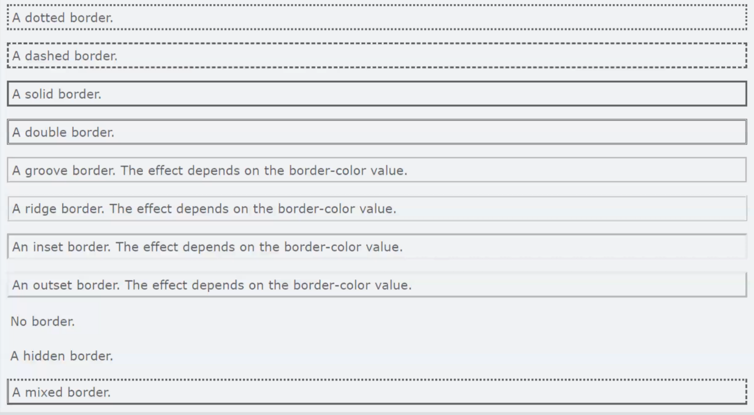

Transform property

<https://developer.mozilla.org/en-US/docs/Web/CSS/transform>

<https://www.w3schools.com/cssref/css3_pr_transform.php>

Elementlerin transformasiyasini teyin edir.

* Scale: cekisini deyisir
* Skew: X veya Y oxu uzre derecelendirir
* Rotate: verilmis derece uzre cevirir
* Translate: X veya Y oxu uzre hereketlendirir

CSS display

Display ozelliyi html elementlerinin block veya inline element olmasini teyin edir

Inline: inline element olur(eyni setirde olur width)

Height ozellikleri olmur oz kontenti qeder yer tutur

Block: block element olur(sutunlarda olur width ve height ozellikleri olur butun setiri tutur)

Inline-block: hem inline hemde block element kimi olur(width ve height ozellikleri olur eyni setirde olur)

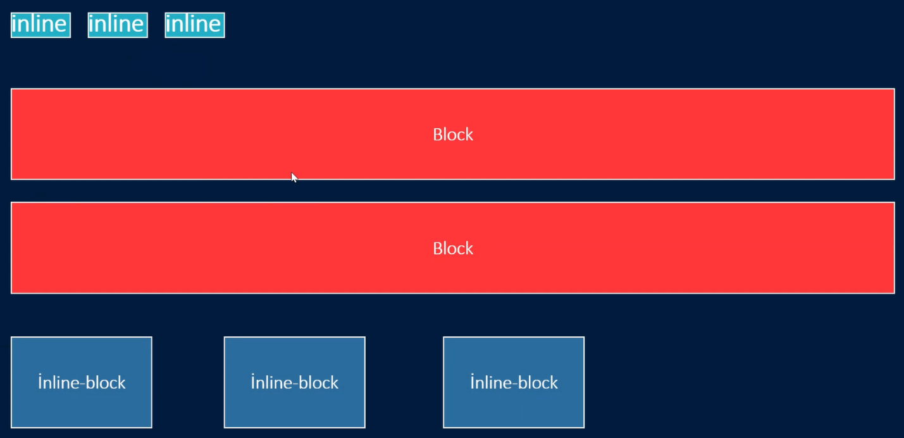

Background property

Arxa planda olan ozellikler ucun

Repeat: verilen sekili tekrarlayir

Size: cover merkeze dogru fokuslayir,contain tam sekilde gorunen edir

Position: sekili element icinde yerlesdirir

Background-attachment

Clip

Color

Image

Position

Origin

Repeat

Size

Object fit

<https://developer.mozilla.org/en-US/docs/Web/CSS/object-fit?retiredLocale=tr>

<https://www.w3schools.com/css/css3_object-fit.asp>

Sekillerin olculerini uygunlasdirma ucun istifade olunur

Fill: tam sekilde doldurur

Contain: sekil oz aspect nisbetini saxlayir, lakin verilen olcuye uygunlasdirmaq ucun olcusunu deyisdirir

Cover: sekil oz aspect nisbetini saxlayir ve verilen olcusu doldurur. Sekil uygunlasmaq ucun kesilecek

Opacity

Background image

Arxa plani deyisdirmek ucun istifade olunur

url: sekilin linki ile hemin sekili gorunene

gradient: arxa plani xususi gradient edir

url: (sekilin location-u)

linear-gradient(hardan baslayacagi,..,rengler)

<https://www.w3schools.com/css/css_overflow.asp>

<https://www.w3schools.com/css/css_combinators.asp>

<https://www.w3schools.com/css/css_align.asp>

<https://www.w3schools.com/css/css_positioning.asp>

<https://developer.mozilla.org/en-US/docs/Web/CSS>

<https://www.w3schools.com/css/css_float.asp>

<https://www.w3schools.com/css/css_navbar.asp>

<https://www.w3schools.com/tags/tag_noscript.asp>

<https://www.w3schools.com/css/css_display_visibility.asp>

<https://www.w3schools.com/tags/tag_pre.asp>

<https://www.w3schools.com/tags/tag_var.asp>

transition-delay: kecidin baslayacagi zamani teyin edir

transition-duration: kecidin ne qeder muddet cekeceyini teyin edir

transition-property: kecidin hansi ozellik uzre bas vereceyini teyin edir

Shadow

Css’de kolgelendirme ucun shadow-dan istifade olunur.

Elementin kolgelendirilmesi ucun Box-shadow

Yazinin kolgelendirilmesi ucun text-shadow-dan istifade olunur

Box-shadow

Elementin kolgelendirilmesi ucun istifade olunur

Box-shadow: [saga dogru] [asagiya dogru]

Flexbox

Flexbox verilmis konteynerin icindeki elementleri nizamlamaq ve yerlesdirmek ucun istifade olunan en faydali yollardan biridir.

Display flex

Verilmis konteyner icerisindeki elementleri flex elemente(yeni nizamlana bilen) elemente cevirir.

Flex direction

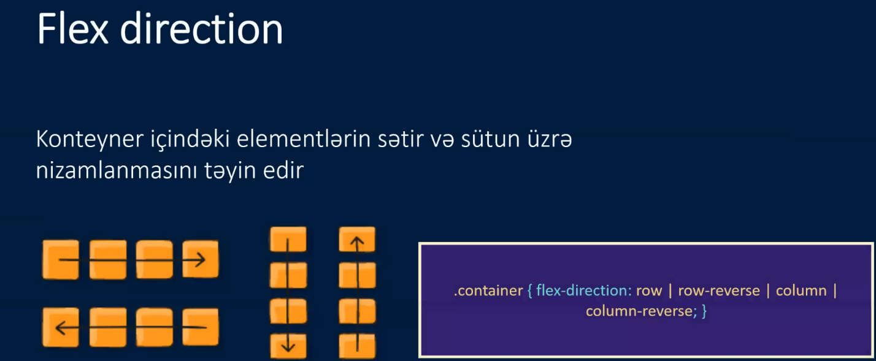

Flex wrap

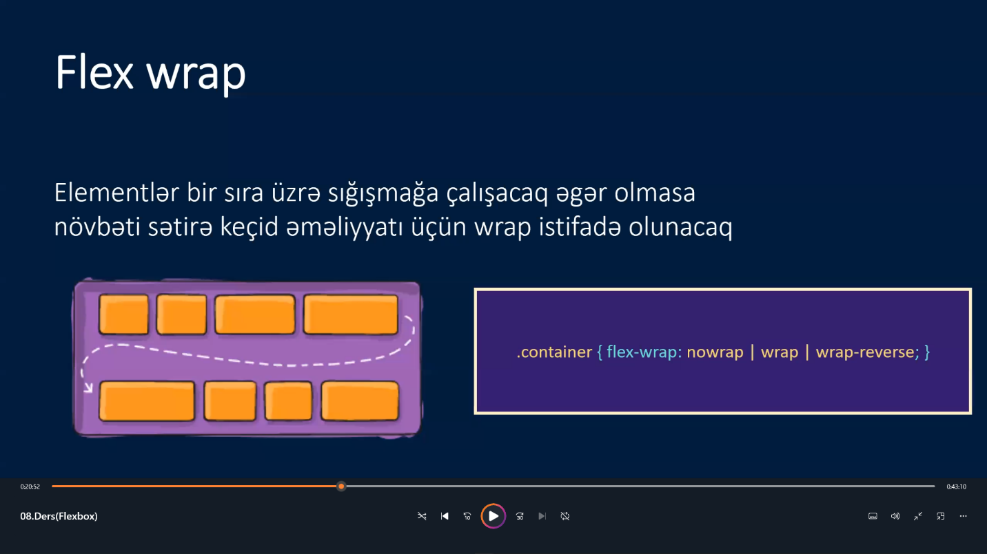

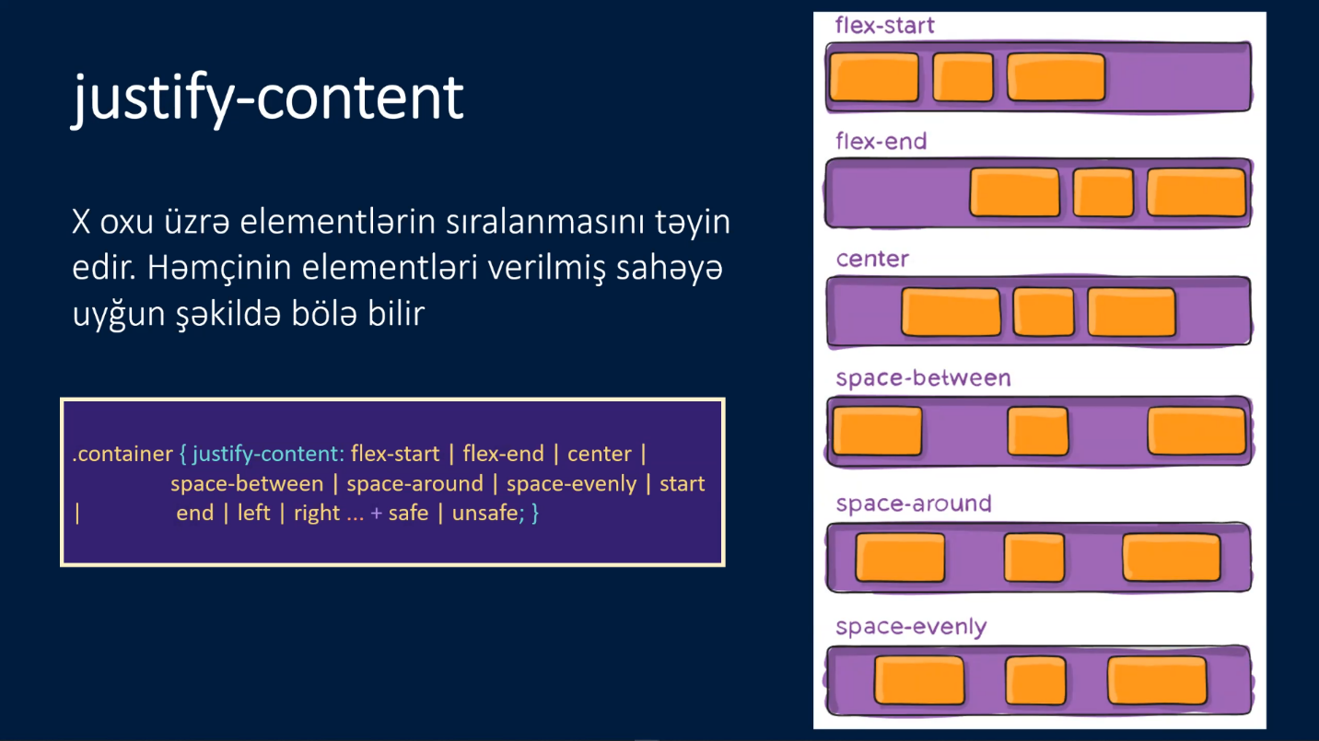

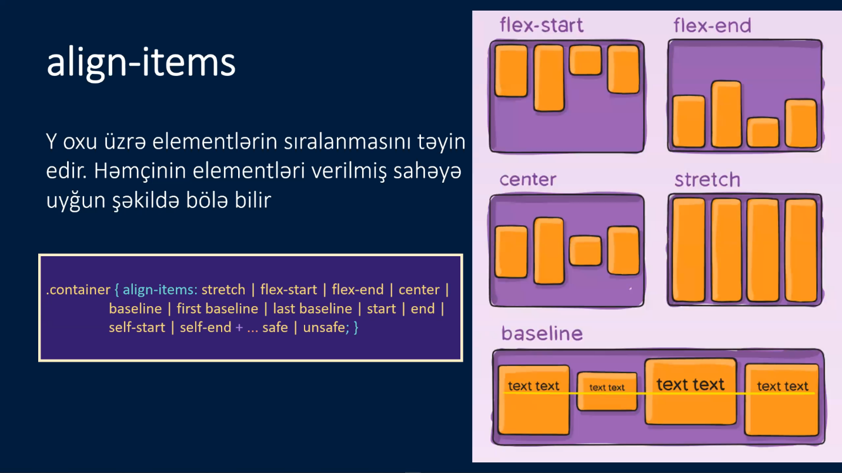

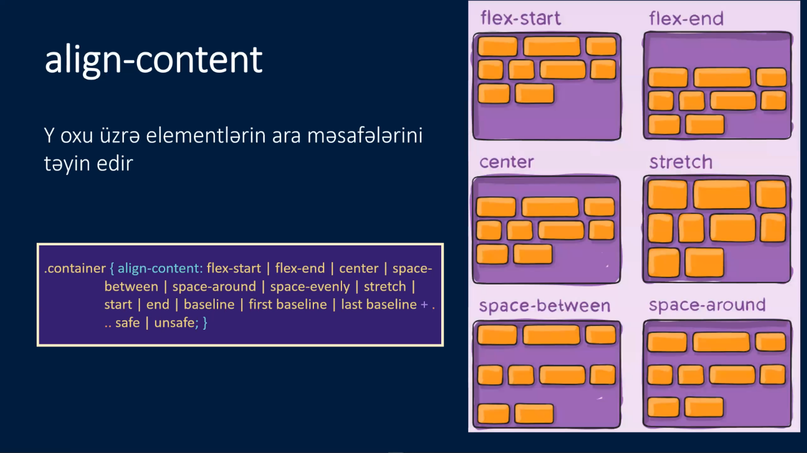

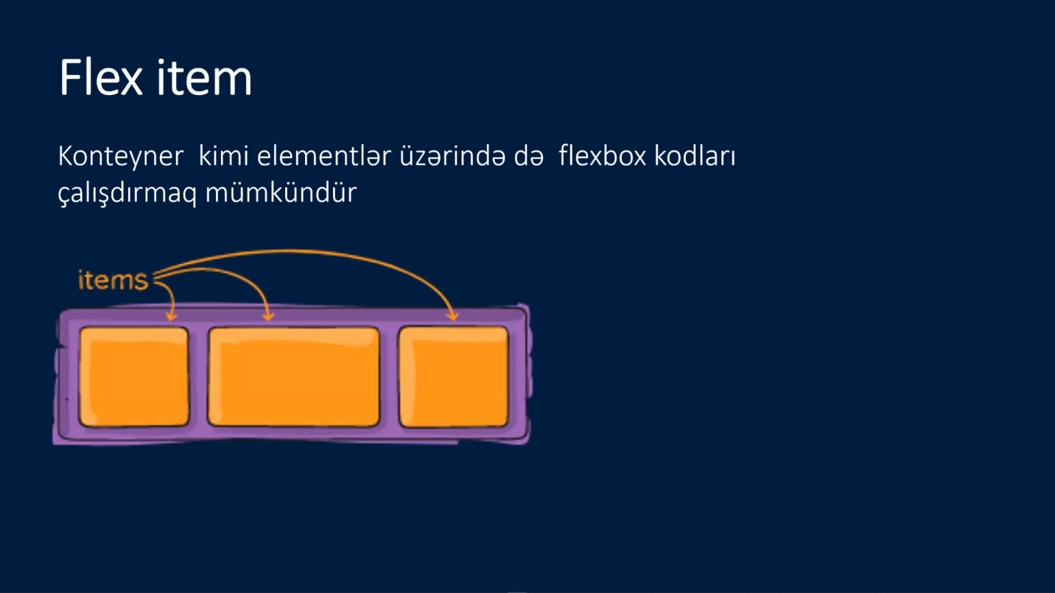

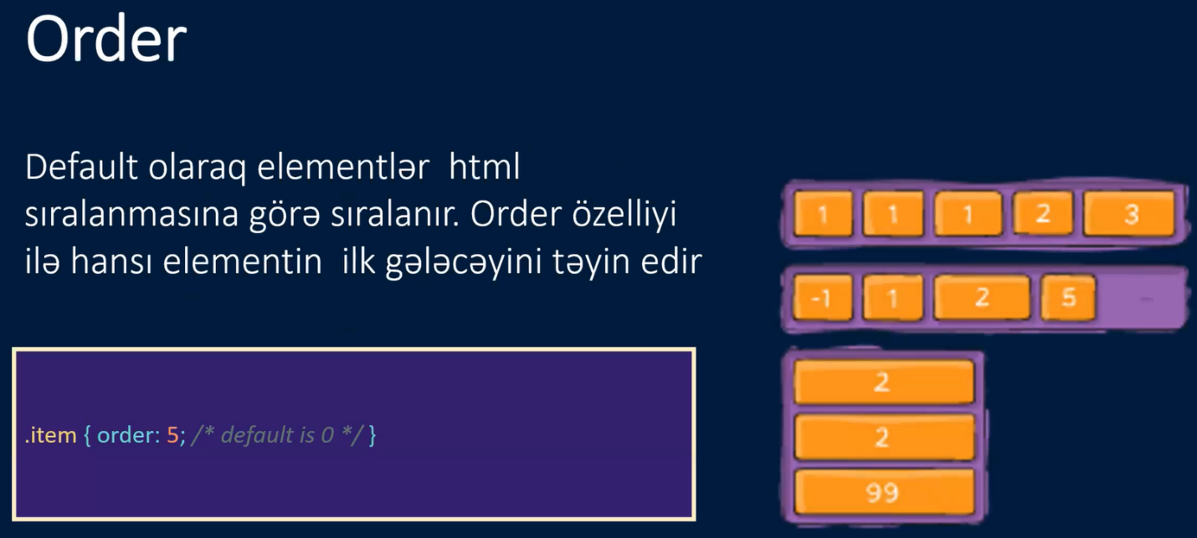

<https://developer.mozilla.org/en-US/docs/Web/CSS/flex-shrink>

<https://www.w3schools.com/cssref/css3_pr_flex-shrink.php>

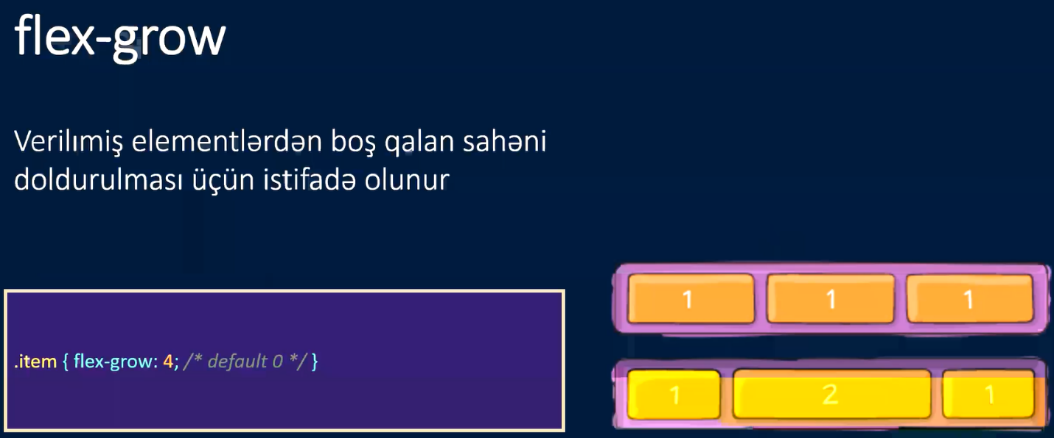

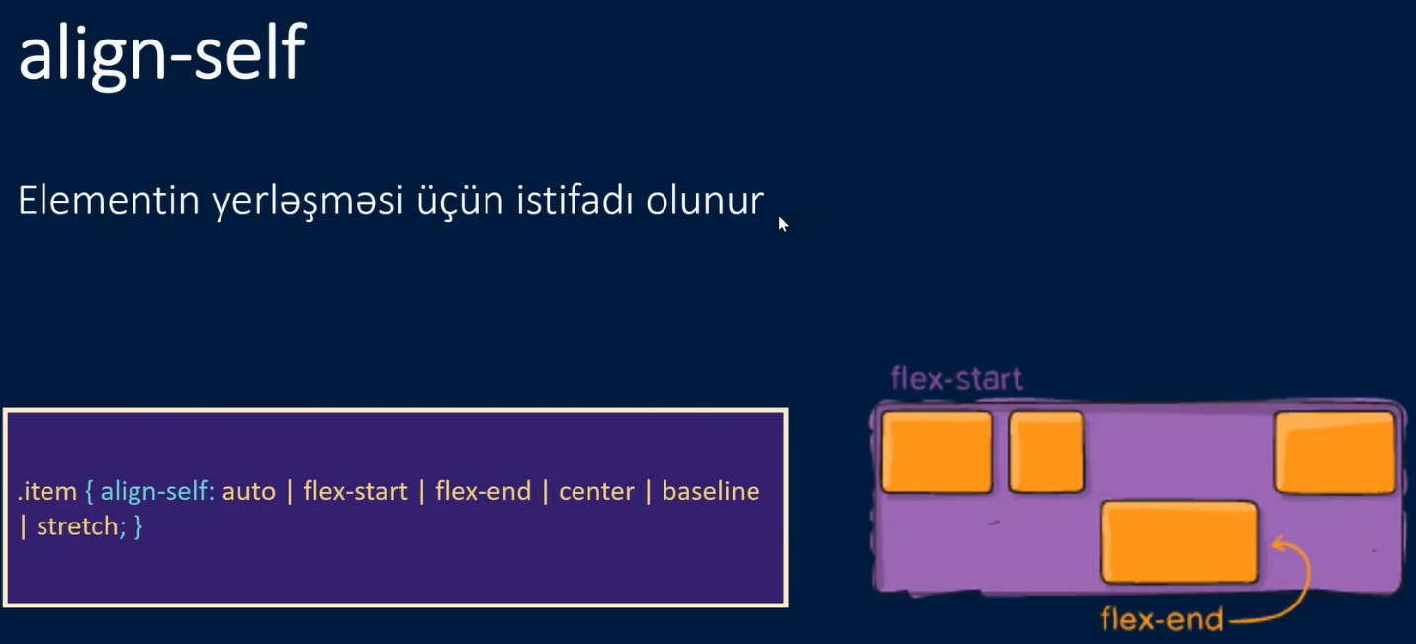

<https://developer.mozilla.org/en-US/docs/Web/CSS/visibility>